Established 1863

BURKES

LICENSED AUCTIONEER

Established 1863

BORGIN

LICENSED AUCTIONEER

Diagon Alley

DIAGON ALLEY

**DIAGON ALLEY**

DIAGON ALLEY

DIAGON ALLEY

DIAGON ALLEY

 



BORGIN

&

BURKE

Established 1863

Knockturn Alley

https://www.therpf.com/forums/threads/ultras-knockturn-alley-sign-harry-potter-diagon-alley-finally-finished.233187/

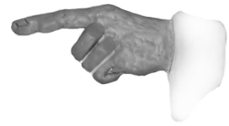

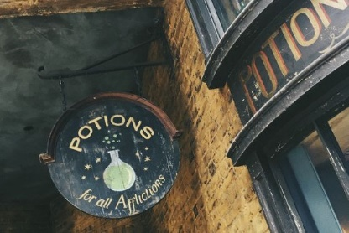

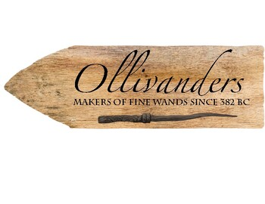 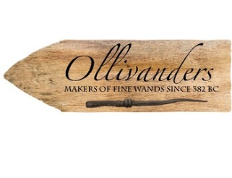

BORGIN

&

BURKE

Established 1863

BORGIN

&

BURKE

Established 1863

BORGIN

&

BURKE

Established 1863





